Operating Systems Programming Assignment Unit 7

Anonymous Student

University of the People

Operating Systems Programming Assignment Unit 7

This report discusses the running of and subsequent data provided by the NTFSInfo utility, which shows “information about the NTFS volumes” (Russinovich, 2016). NTFS is short for Windows NT file system (“NTFS Basics”, n.d.).

**1. Attach YOUR screenshot from running NTFSinfo utility.**

Here is the screenshot showing the results of running NTFSInfo utility from my computer’s command window:

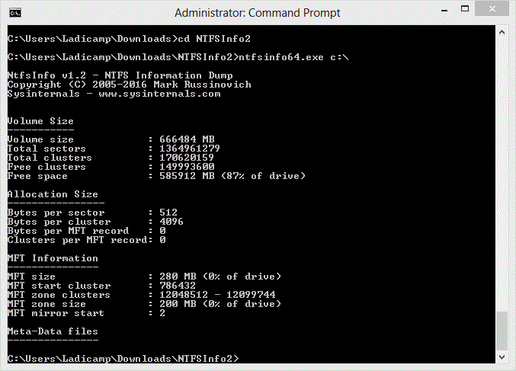

**2. List number of sectors and define what it means.**

As you can see in the screenshot provided (under Volume Size), the total number of sectors the utility found are 1,364,961,279. According to Fisher, sectors are “the smallest portion of the disk that can be used to store data” (2018) and they are uniformly sized. As such, my system has been divided into 1,364,961,279 similarly sized sectors, which is where data can be stored.

**3. List number of total clusters and define what it means.**

Also in this screenshot (again under Volume Size), is listed the total clusters found, which were 170,620,159. Systems usually avoid allocating individual sectors, instead they allocate Clusters of sectors to reduce fragmentation (Fisher, 2018; “NTFS Basics”, n.d.). Therefore, the number of clusters of sectors that my system has the ability to allocate is 170,620,159.

**4. List number of bytes per cluster and define what it means**

In the same screenshot (under Allocation Size) the bytes per cluster are reported to be 4096. 4096 bytes is the current size of the clusters of sectors that my system will allocate to on the hard drive; therefore my system will allocate no fewer than 4096 bytes for data, but this number can be modified(Fisher, 2018; “NTFS Basics”, n.d.).

**5. Translate the number of free clusters from decimal number to a hexadecimal.**

Under the Volume Size section of the screenshot, the number of free clusters is 14,993,600, which can be translated into hex (“Decimal to Hex converter”, n.d.) like this:

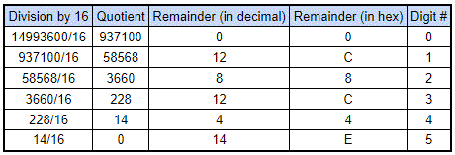

Therefore, the decimal value 14,993,600 translates into E4C8C0 hex.

**Conclusion**

This week, we were tasked with installing and running a utility that shows “information about the NTFS volumes” (Russinovich, 2016), namely NTFSInfo. By using this utility, we are able to discern the total # of sectors in a system, the total # of clusters it has, the # of bytes per cluster, and how many clusters are free. In addition to this we were asked to convert the decimal value of free clusters to a hex value. All of this furthered our learning of how memory management and operating systems work in a modern system.

References

Arpaci-Dusseau, R. & Arpaci-Dusseau, A. (2012). *Operating Systems: Three Easy Pieces. Madison, WI: University of Wisconsin-Madison.* Retrieved from <http://pages.cs.wisc.edu/~remzi/OSTEP//>

“Decimal to Hex converter” (n.d.). *RapidTables*. Retrieved from <https://www.rapidtables.com/convert/number/decimal-to-hex.html>

Fisher, T. (2018). What is a Sector? Explanation of Disk Sector Sizes and Repairing Damaged Sectors. *Lifewire*. Retrieved from <https://www.lifewire.com/what-is-a-sector-2626003>

“NTFS Basics.” (n.d.). *NTSF.com*. Retrieved from <http://www.ntfs.com/ntfs_basics.htm>

Russinovich, M. (2016). NTFSInfo v1.2. *Windows Sysinternals.* Retrieved from <https://docs.microsoft.com/en-us/sysinternals/downloads/ntfsinfo>